Calculation Policy
Maths
Document control
Prepared By | Shaun Leathers
Authorised By

Progression Towards a Standard Written Method of Calculation

Introduction:

This calculation policy has been written in line with the programmes of study taken from the National Curriculum and the Maths No Problem Scheme used at Co-op Academy Portland for mathematics. It provides guidance on appropriate calculation methods and progression. The content is set out in stage blocks under the following headings: addition, subtraction, multiplication and division.

Vision for maths at Co-op Academy Portland:
Our vision of maths is that the pupils of Co-op Academy Portland become confident, capable and creative learners in mathematics through robust teaching and modelling. This will be achieved through a range of practical and contextual lessons teaching the key skills which enable our pupils to become well-rounded and active members of our society. Our pupils will be able to become efficient in steps and strategies; using the more effective methods to solve problems and calculate questions. They will make links to prior learning and adapt a flexible approach to problem solving which will build fluency in not only mathematics but the wider curriculum as well. Our pupils’ mathematical learning should go beyond memorising facts but develop an understanding of what they are doing and why. Through this, the pupils of Co-op Academy Portland are equipped with mathematical skills that can be applied in their lives.

Aims of the Policy:
-To ensure consistency and progression in our approach to calculation across the whole school to ensure our pupils gain access to a robust and consistent maths curriculum through several methods using the ‘I do, we do, you do’ model
-To ensure that children develop an efficient, reliable, formal written method of calculation for all operations
-To ensure that children can use these methods accurately with confidence and understanding

How to Use This Policy:

Use the policy as the basis of your planning but ensure you use previous or following stages’ guidance to allow for personalised learning. Always use Assessment for Learning to identify suitable next steps in calculation for groups of children.

If, at any time, children are making significant errors, return to the previous stage in calculation.
Staff are to build into their lessons as much pre-learning as possible through using what the children already know as a baseline for success. In order to develop fluency, staff are to ensure a phase, topic or number is thoroughly explored through making links to other areas of learning. Staff should develop their planning to reflect a thread of learning throughout the year which revisits content taught so our pupils are consistently using and applying key skills. Core knowledge sessions/LbQ (15 minutes) and the ‘Do Now Quiz’ are used daily to bolster and refresh learning.

Always use suitable resources, models and images to support children’s understanding of calculation and place value, as appropriate.

Encourage children to make sensible choices about the methods they use when solving problems.
Remember that the varied or conceptual fluency examples are not exhaustive examples; use other examples in conjunction with these to provide a broad learning experience.

Times Tables Knowledge
The current National Curriculum states that children should know their times tables up to 12x12 by the end of Year 4. Knowing each times table thoroughly and confidently is essential for moving on to most areas within mathematics including but not limited to: division, fractions, decimals and percentages.

The DfE says that the Year 4 multiplication check is part of a focus on mastering numeracy, giving children the skills and knowledge they need for secondary school and beyond. The purpose of the Multiplication Tables Check (MTC) is to determine whether pupils can recall their multiplication tables fluently (being able to answer times tables questions accurately and quickly, without having to work out the answers).

Children who know their times tables facts will be able to answer questions more quickly and be able to focus on using other maths strategies in more complex problems rather than being slowed down by multiplication. Knowing times tables can also increase a child’s confidence levels, as this part of the question becomes easy.

At Co-op Academy Portland, we use Times Tables Rock Stars to support children in their learning as well as LbQ. These are interactive websites which enable children to practise their times tables and compete with other children across the school.

Representations:

The key to successful implementation of a calculation policy is the consistent use of representations (model and images that support conceptual understanding of mathematics) and this policy promotes a range of relevant representations, across the primary years.

Mathematical understanding is developed through use of representations that are first concrete (e.g. Dienes apparatus, cubes), then pictorial (e.g. array, place value counters), finally to then facilitate abstract working (e.g. column addition, long multiplication).

This policy guides teachers through an appropriate progression of representations, and if at any point a pupil is struggling, they should revert to familiar pictorial and/or concrete materials/ representations as appropriate.

EYFS | Number and pattern | Shape, Space and Measure | Problem Solving
Concrete | 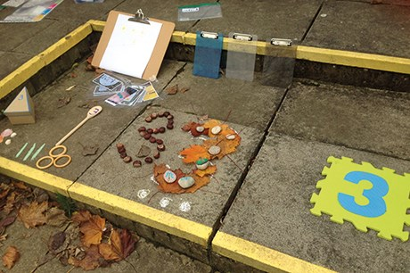  Use a range of resources around the classroom and outdoor area to support finding numbers and patterns. | 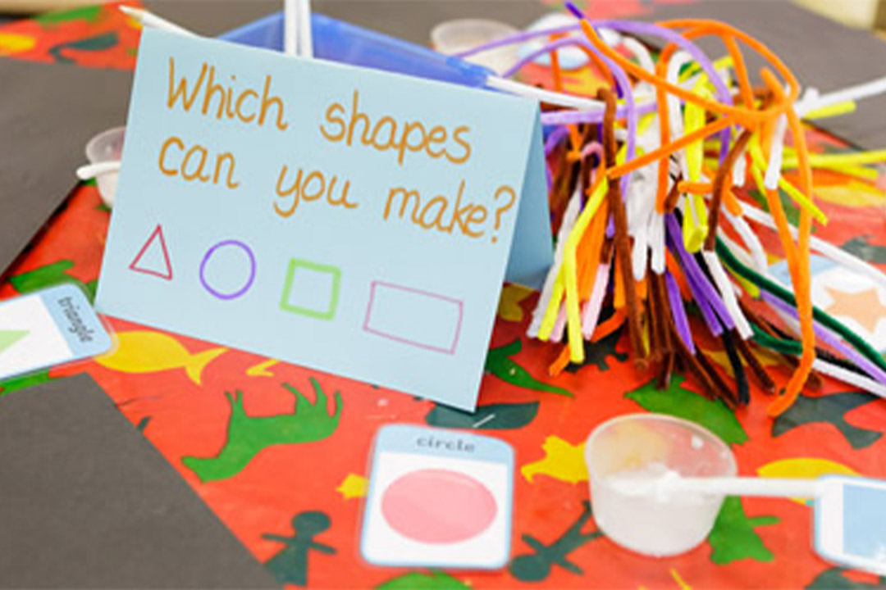  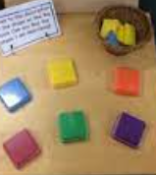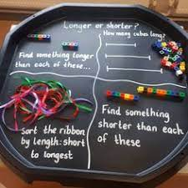 | 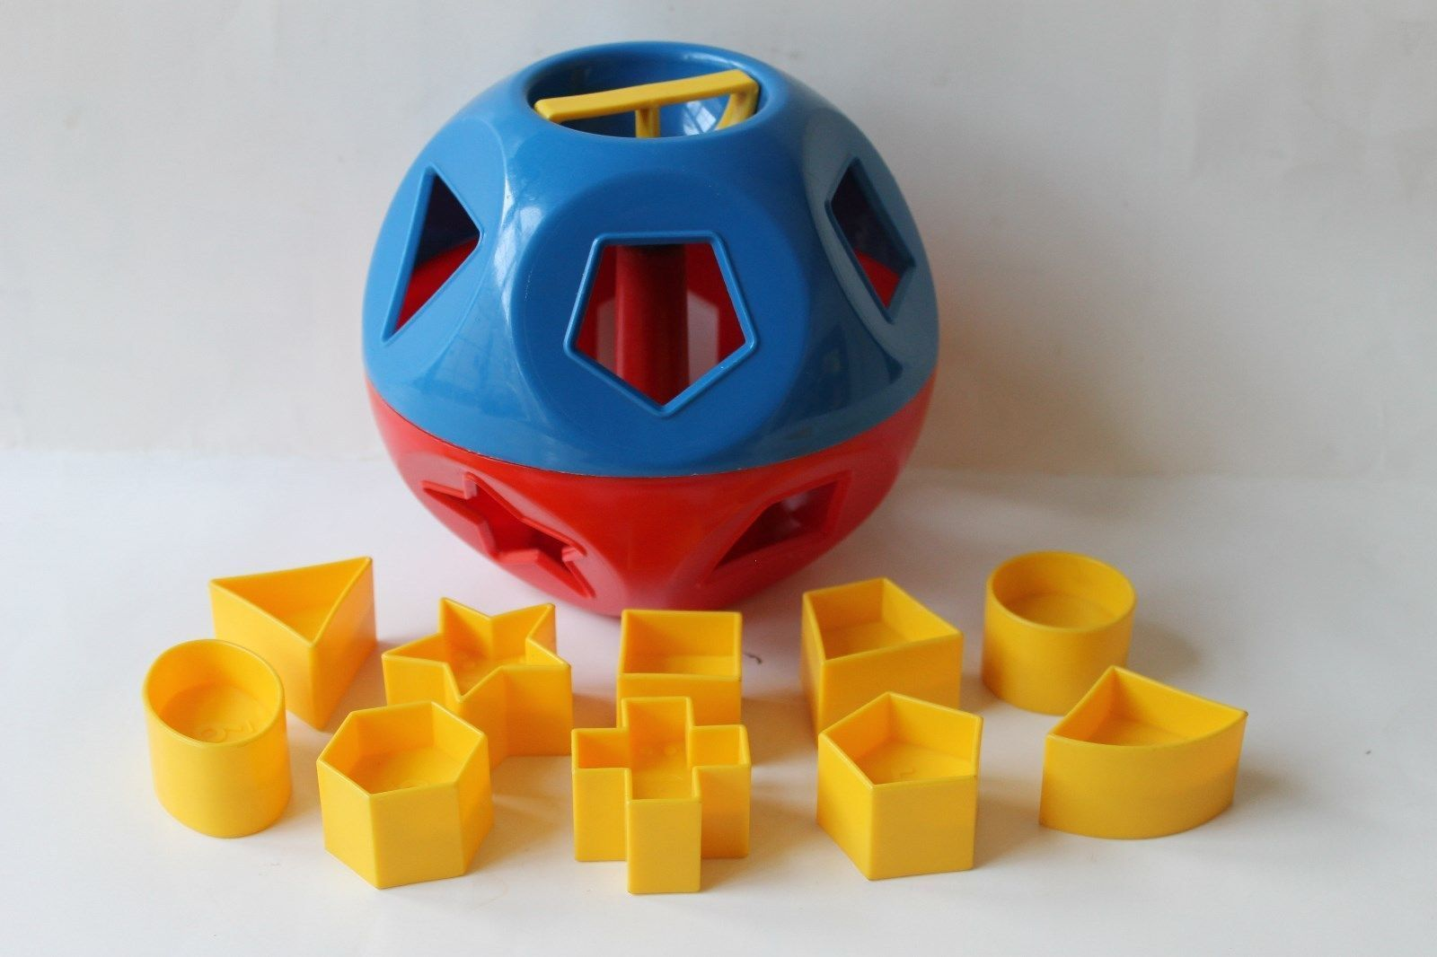  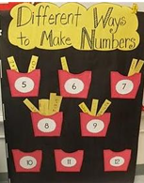  Problem-solving involves reflection and thought. The adult can help by modelling strategies and encouraging children to talk about their methods.
Pictorial | 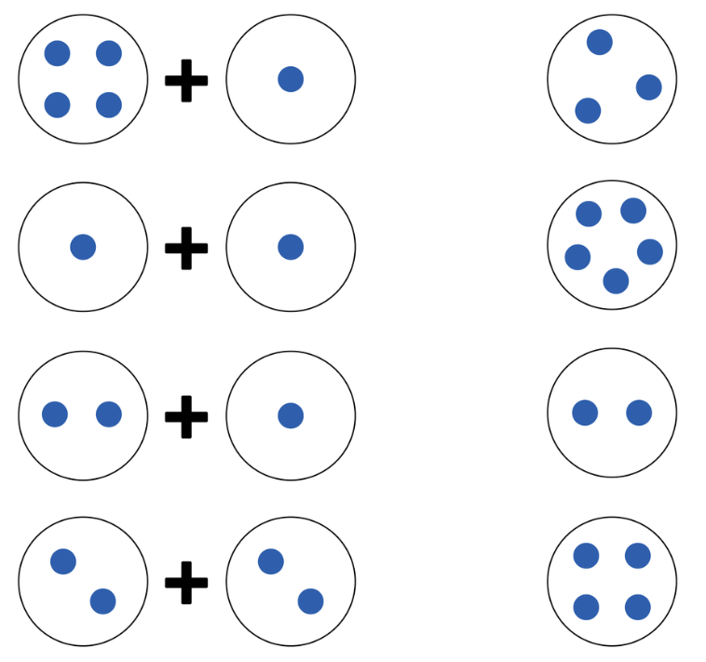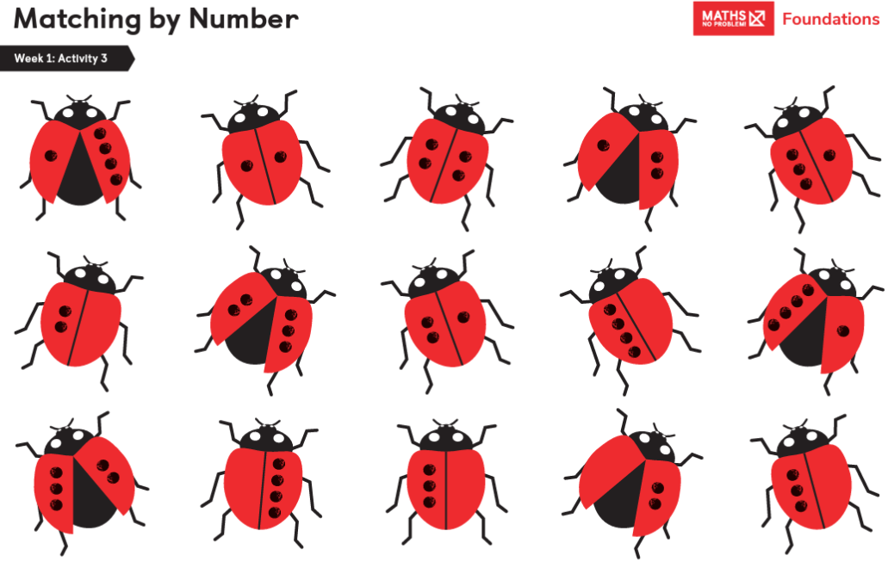 | 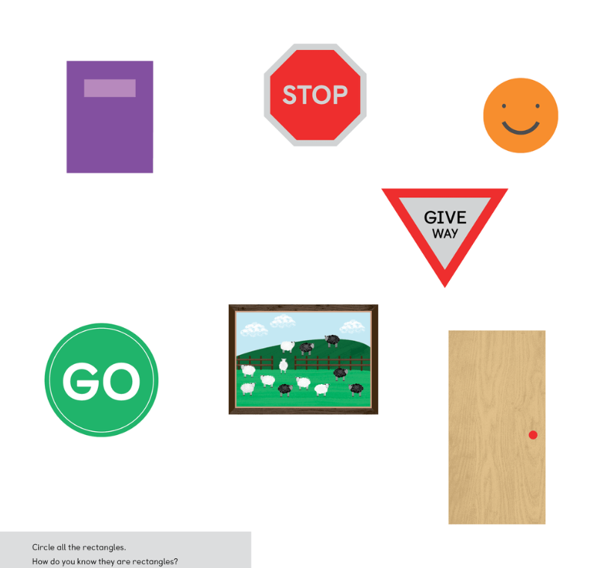
Abstract | Matching values example  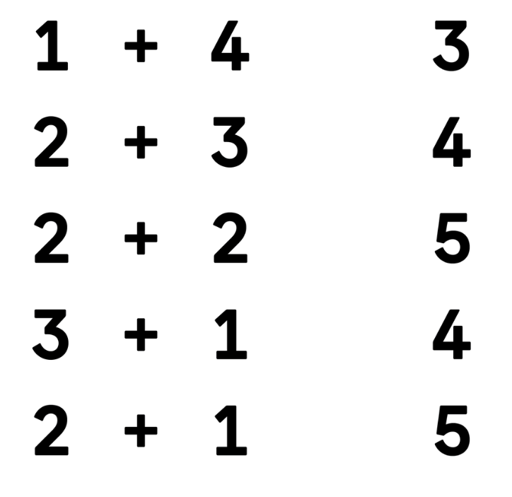

Year 1 | Addition | Subtraction | Multiplication | Division
Concrete | 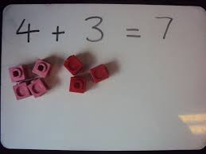  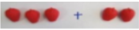  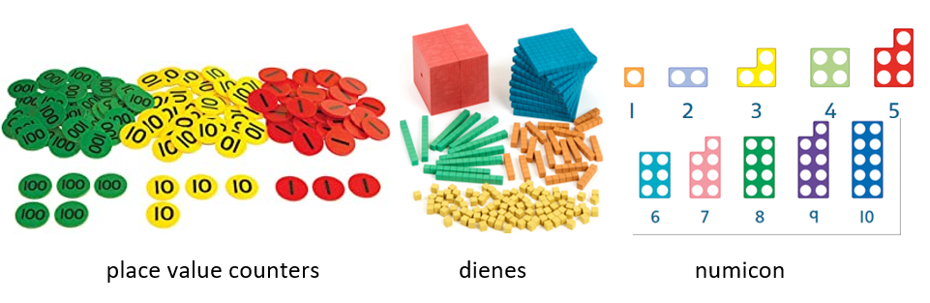  Use a range of resources such as Base 10, cubes, counters etc to visually represent your questions. | 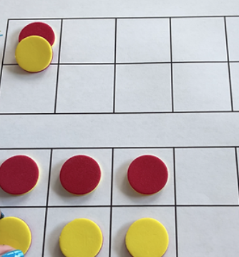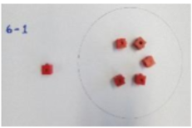  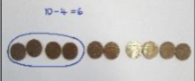 |   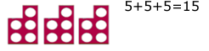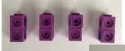  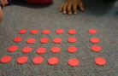 | 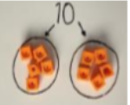  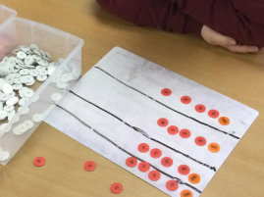
Pictorial | 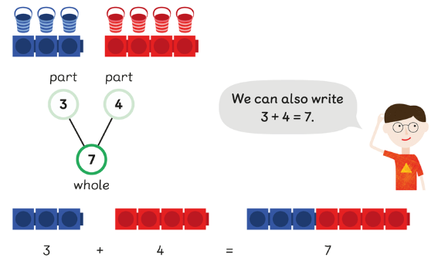  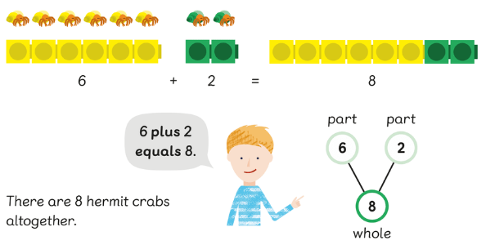  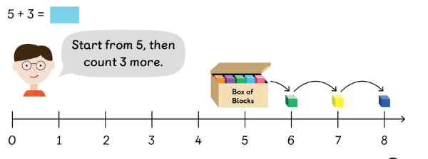 | 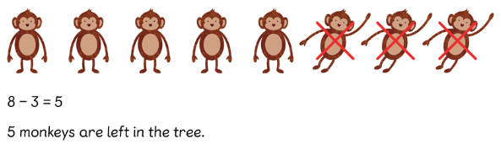  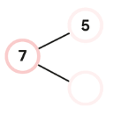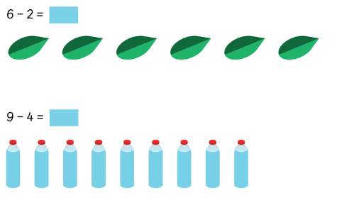  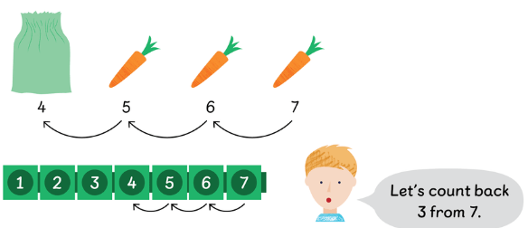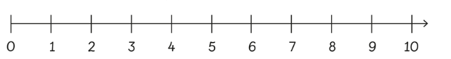 | 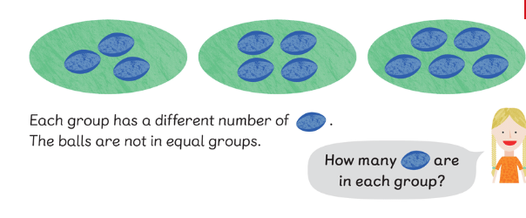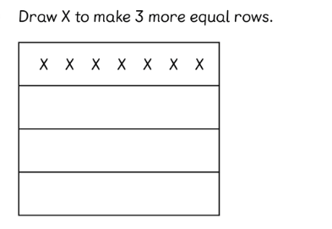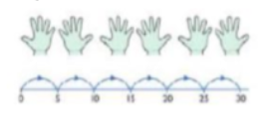  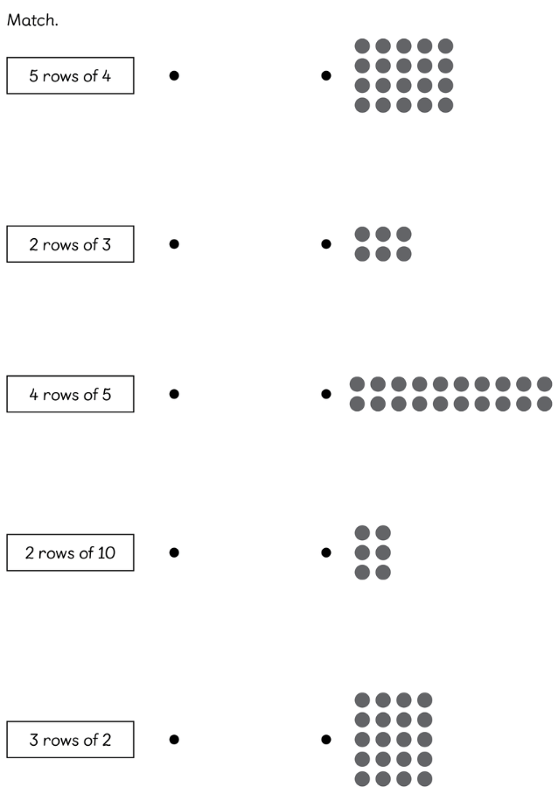 | 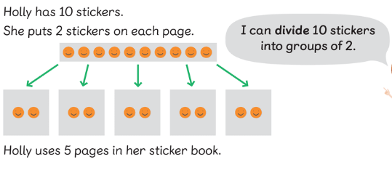  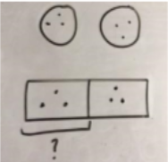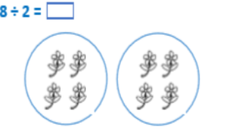
Abstract | 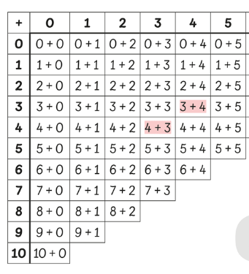  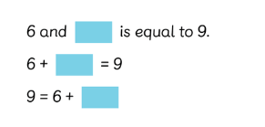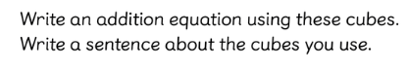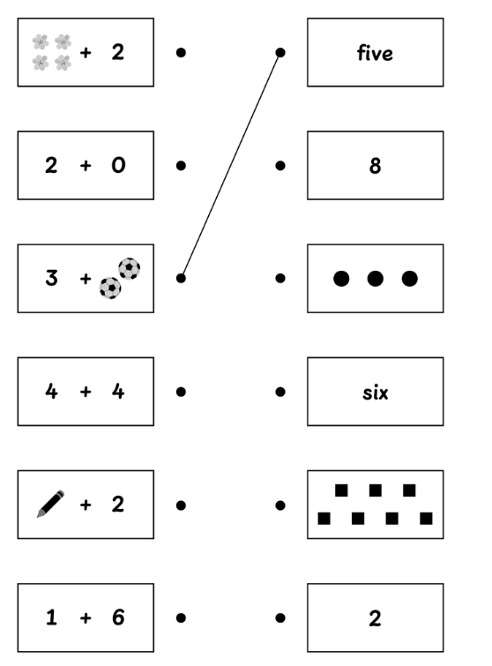 | 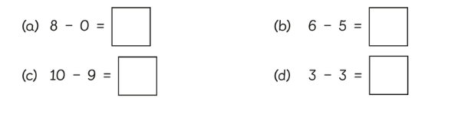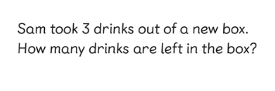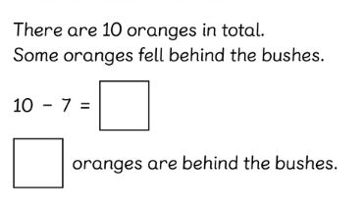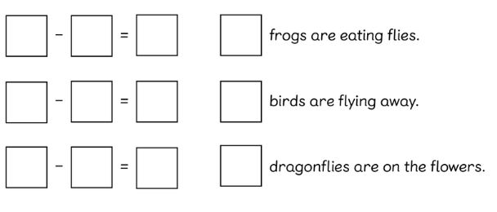 | 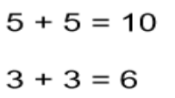  Count in multiples of a number aloud.  Write number sentences with multiples of numbers.  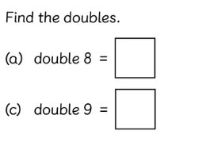 | 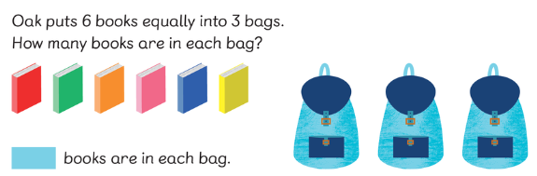  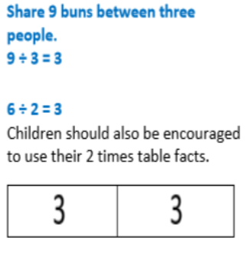

Year 2 | Addition | Subtraction | Multiplication  Children should know 2s, 5s and 10s by the end of year 2. | Division
Concrete | Use a range of resources such as Base 10, cubes, counters etc to visually represent your questions.  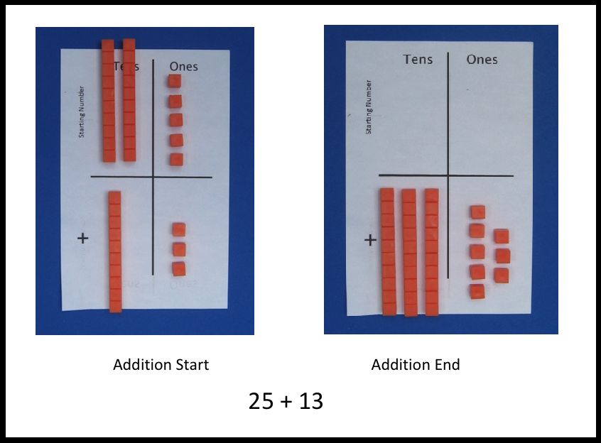  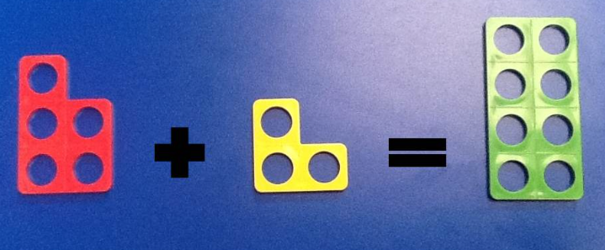  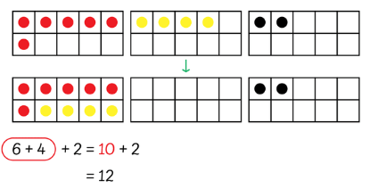 | 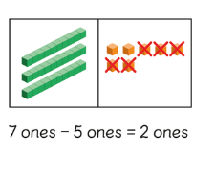  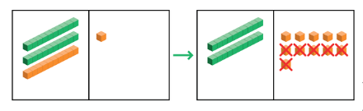  Use base 10 or counters to show exchanging. | 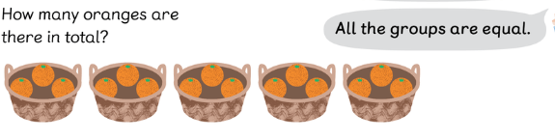  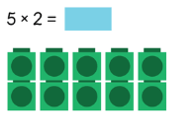  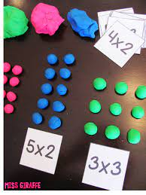Use counters, cubes, numicon or real life objects to support with learning 2s, 5s and 10s. | 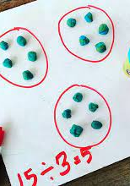
Pictorial | 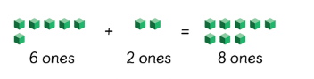  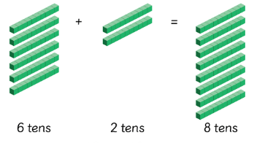  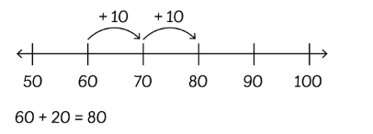  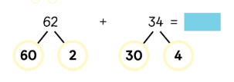 | 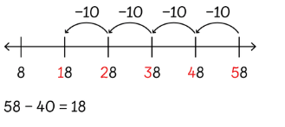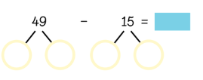  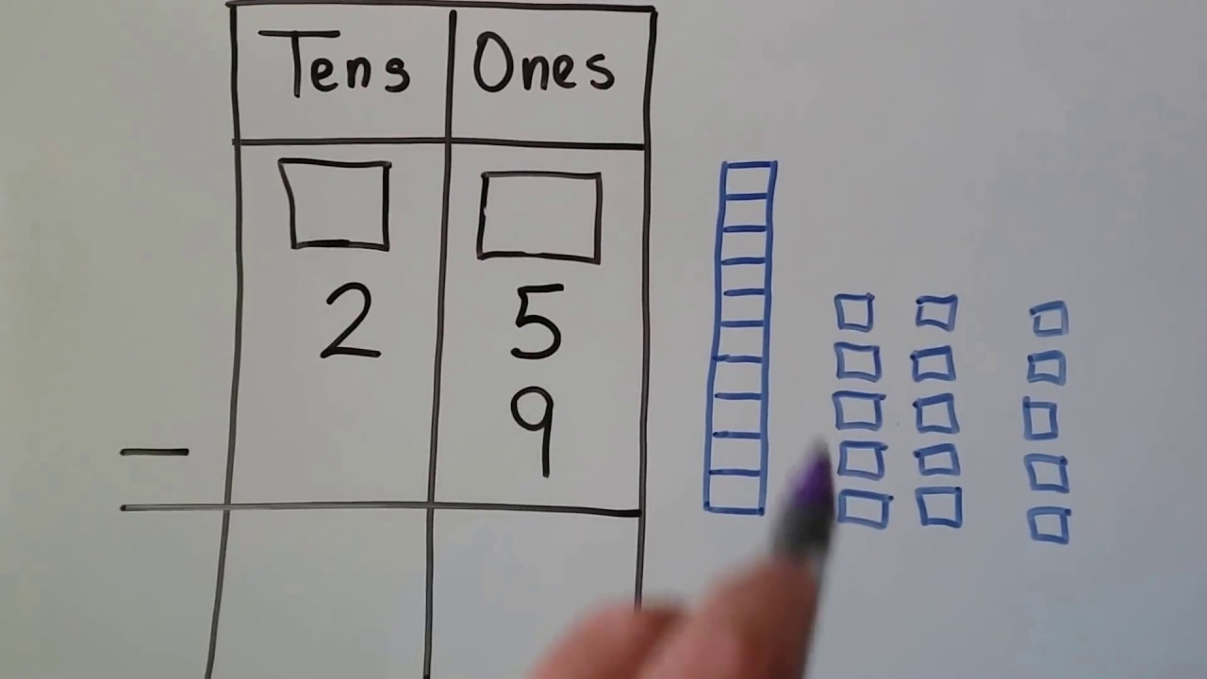 | 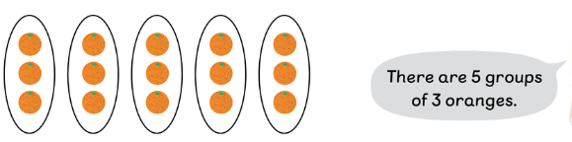  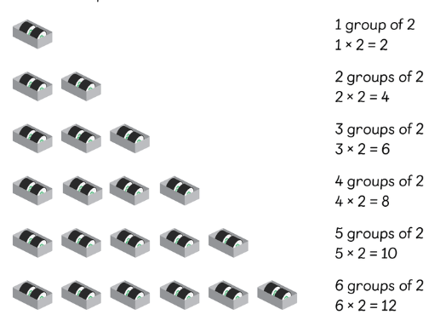  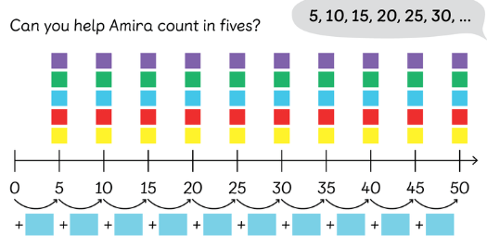  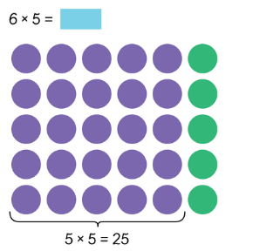 | 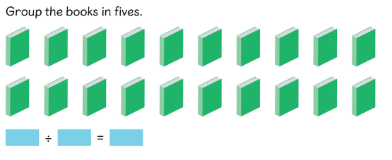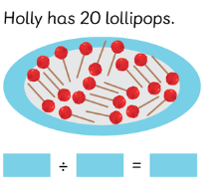  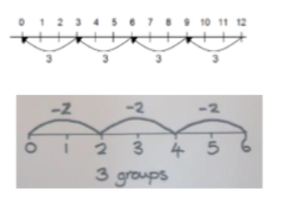
Abstract | 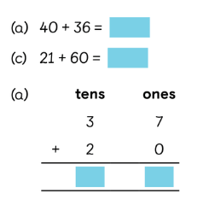  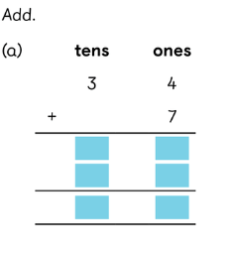 | 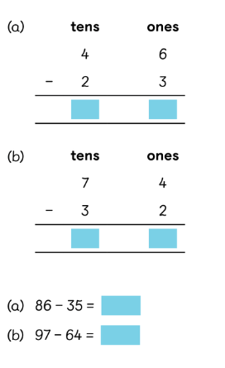 | 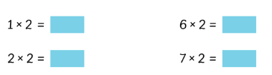 | 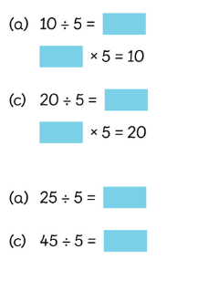

Year 3 | Addition | Subtraction | Multiplication  Children should know 3s, 4s and 8s by the end of Year 3. | Division
Concrete  Use a range of concrete resources in each topic.  Base ten, counters etc. | 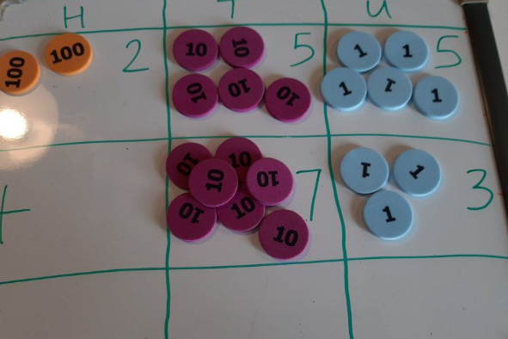  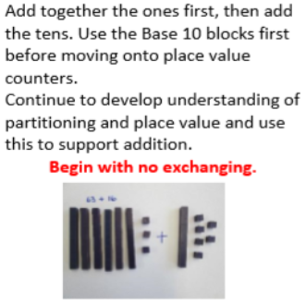  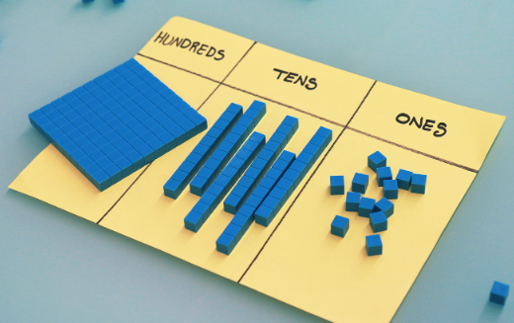 | Same resources as addition can be used for concrete methods. | 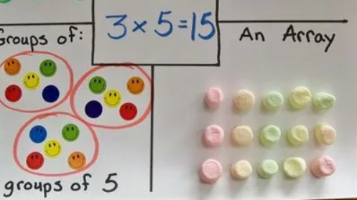  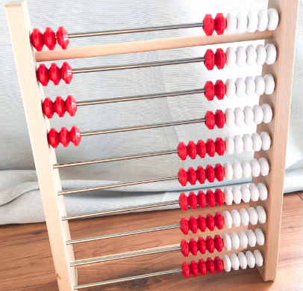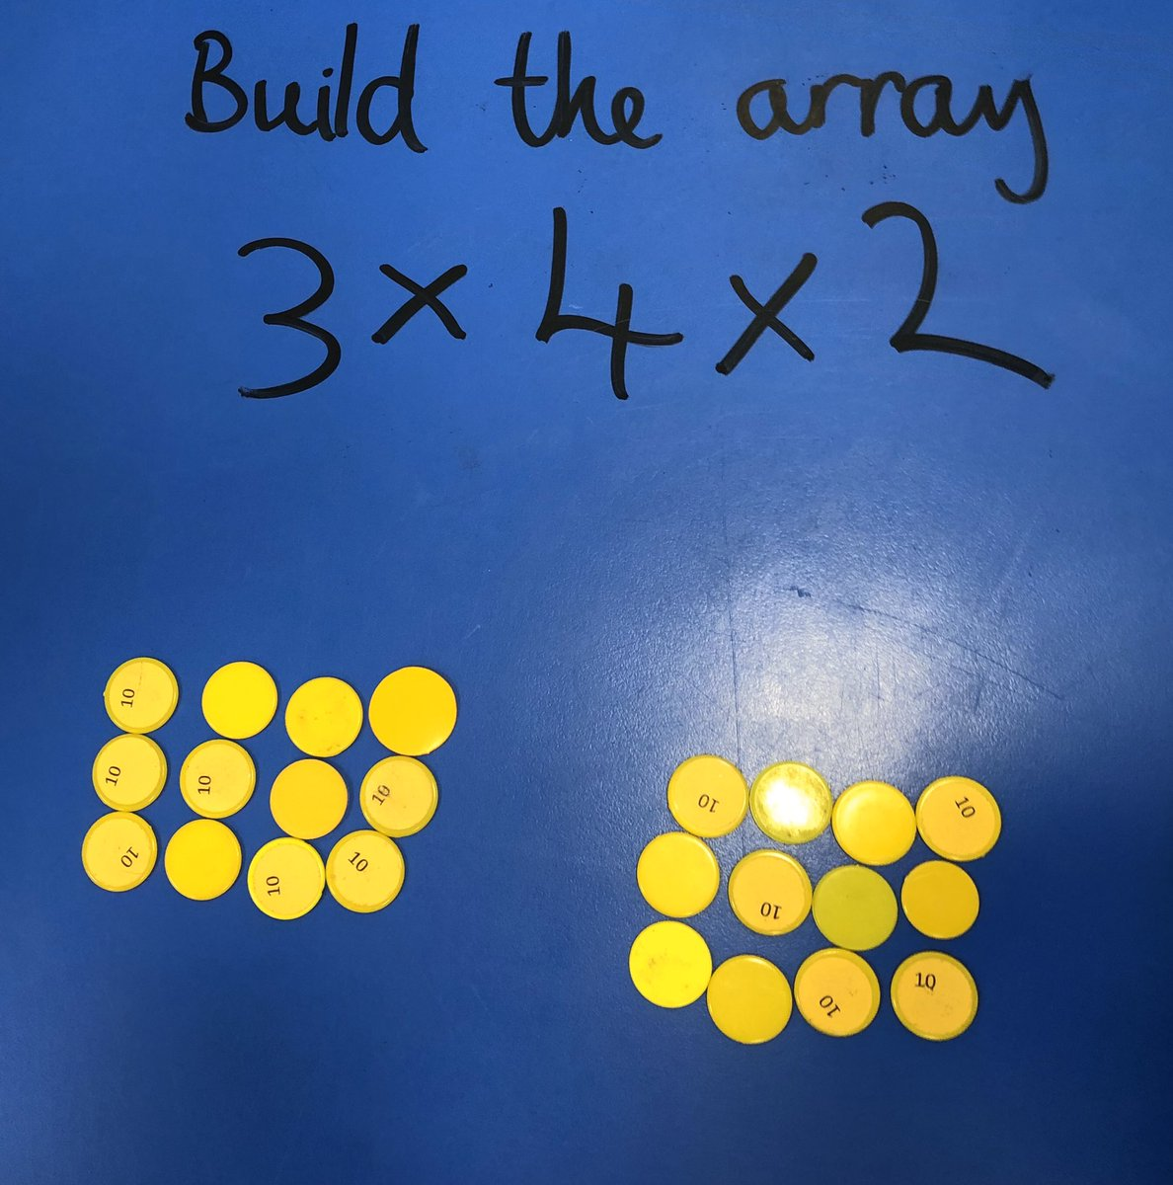 | 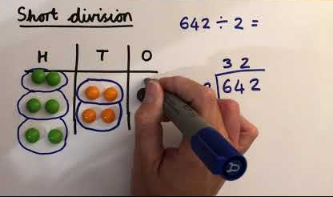  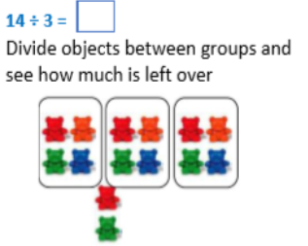
Pictorial | 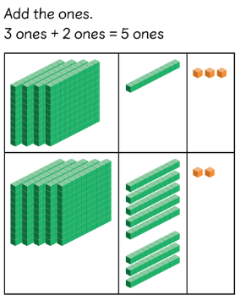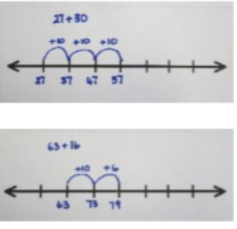  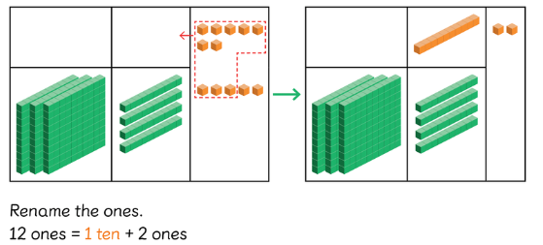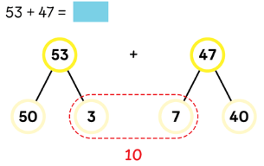 | 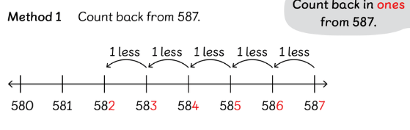  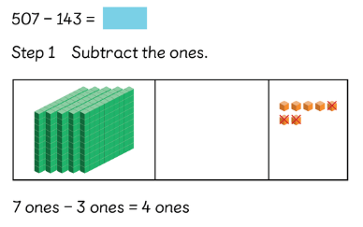  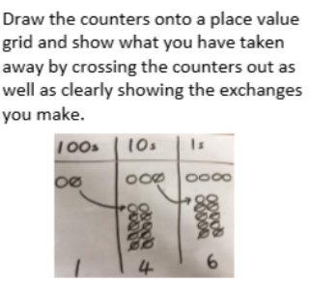 | 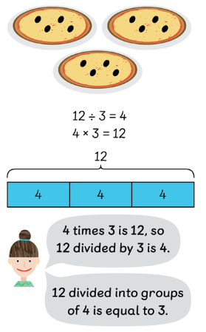  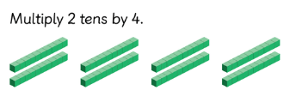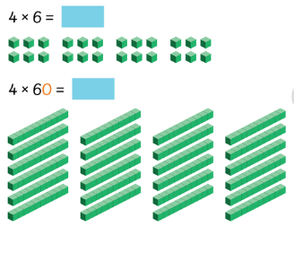 | 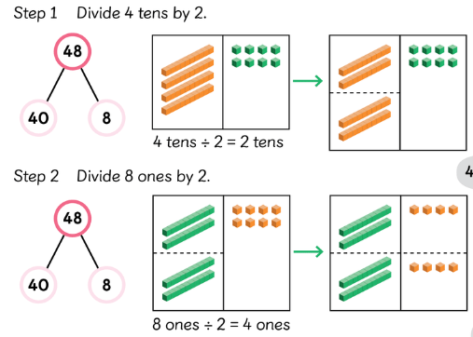  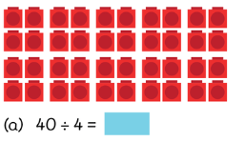  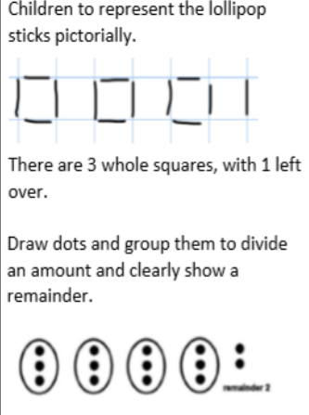
Abstract  Begin to use formal written methods (column method) | 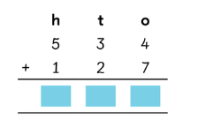  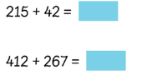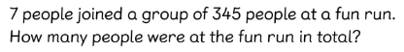 | 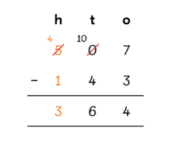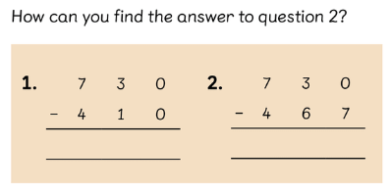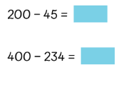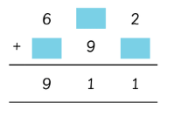 | 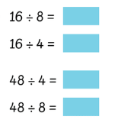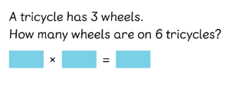  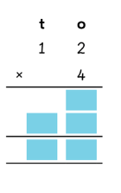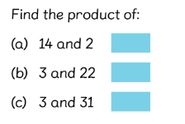 | 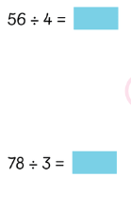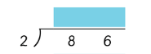  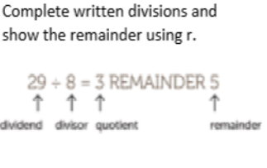

Year 4 | Addition | Subtraction | Multiplication  Children should know all times tables up to 12x12 by the end of year 4 in readiness for their multiplication check. | Division
Concrete  Use a range of concrete resources in each topic.  Base ten, counters etc. | Use methods shown in previous year groups with a range of resources: base ten, counters, numicon etc. | Use methods shown in previous year groups with a range of resources: base ten, counters, numicon etc. | 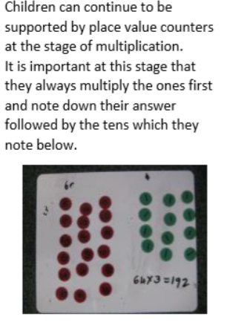  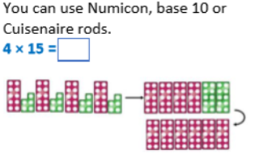 | 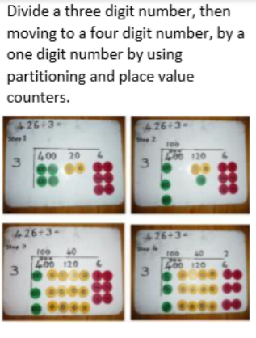
Pictorial | 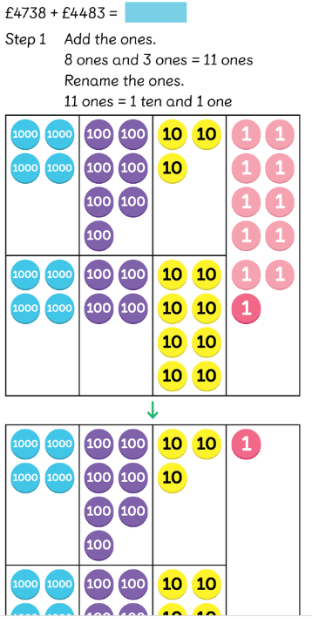  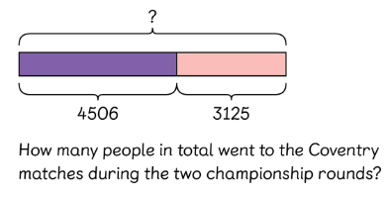  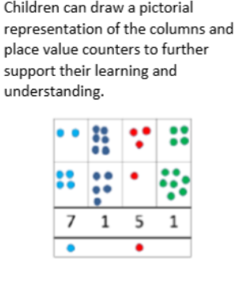 | 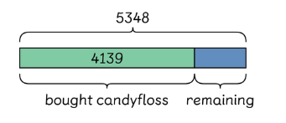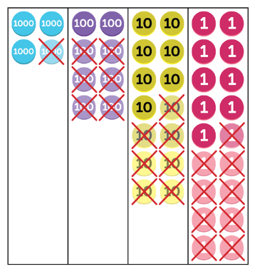 | 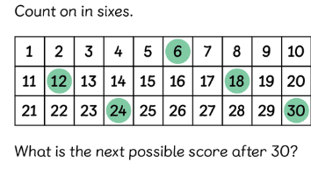  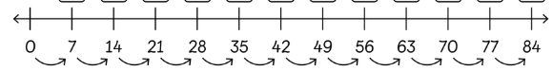  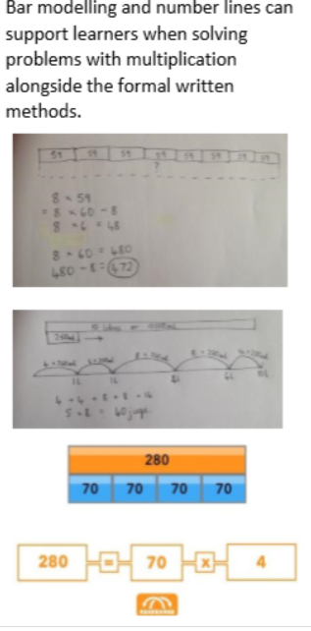  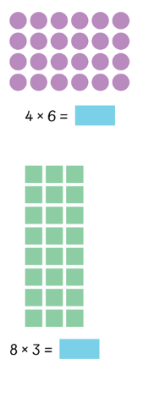 | 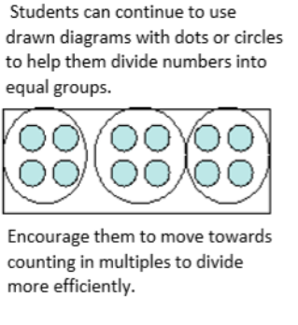  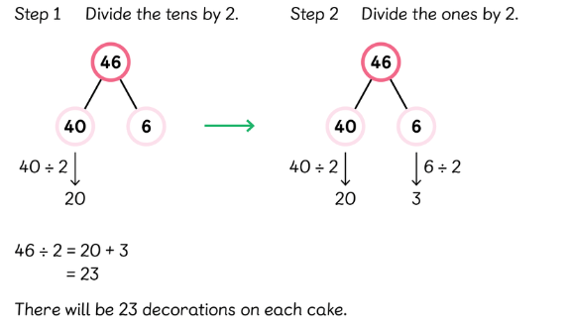
Abstract  Formal written methods to be used. | 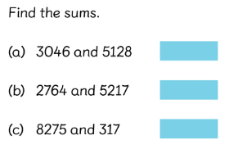  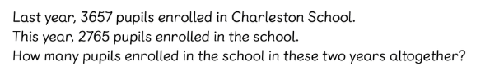  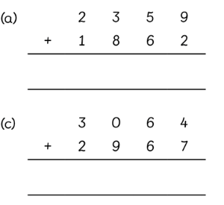 | 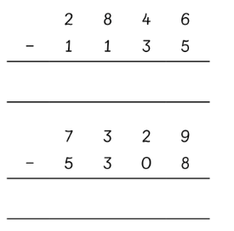  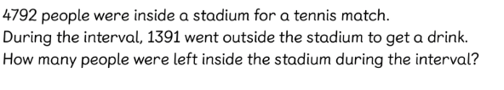  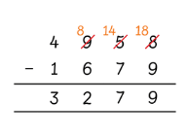 | 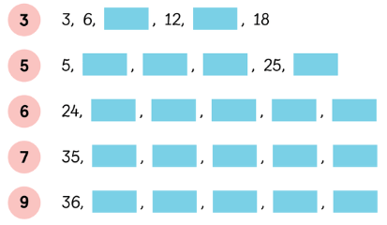  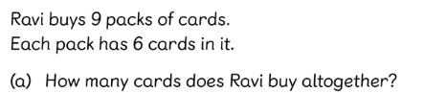  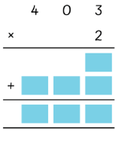 | 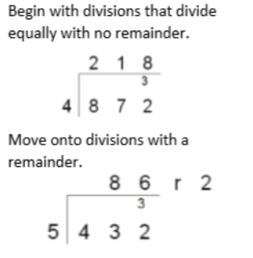

Year 5 | Addition | Subtraction | Multiplication | Division
Concrete  Use a range of concrete resources in each topic.  Base ten, counters etc. | Use methods shown in previous year groups with a range of resources: base ten, counters, numicon etc. | Use methods shown in previous year groups with a range of resources: base ten, counters, numicon etc. | Use methods shown in previous year groups with a range of resources: base ten, counters, numicon etc. | 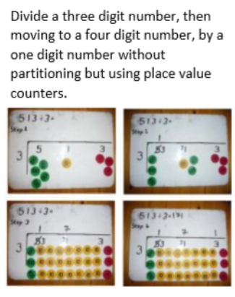
Pictorial | 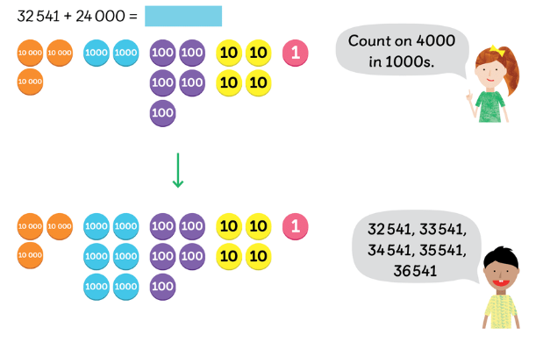  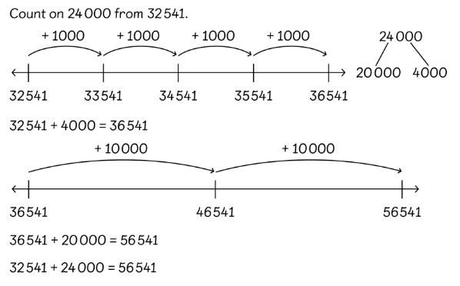  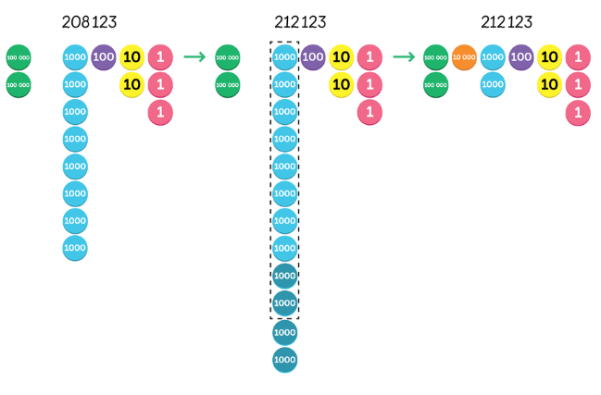 | 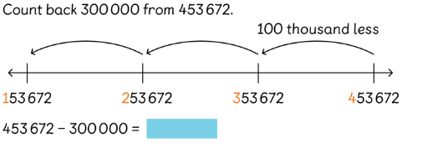  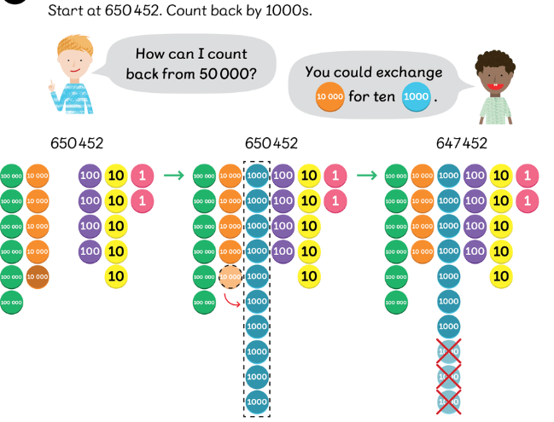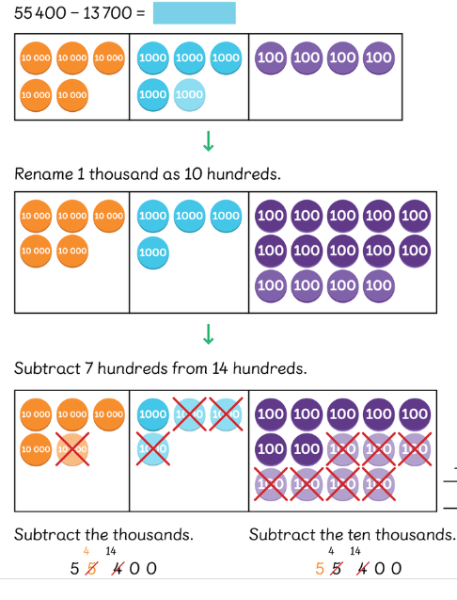 | 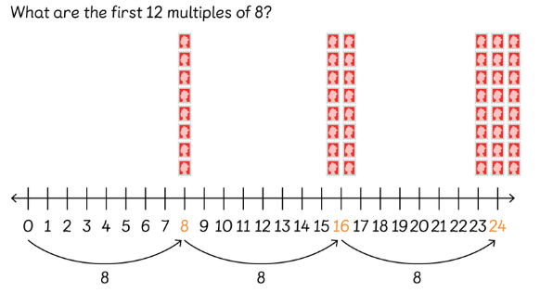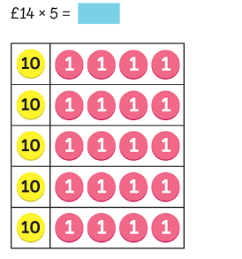  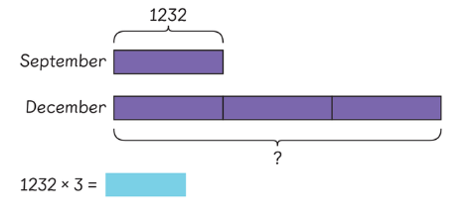
Abstract  Formal written methods to be used. | 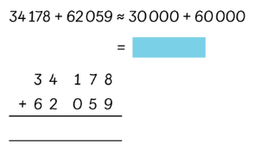  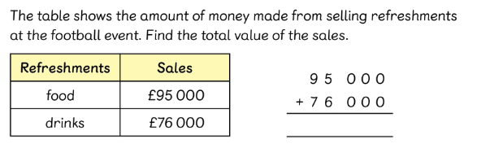 | 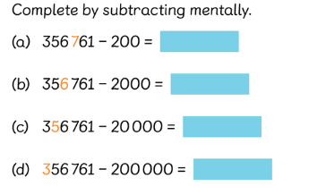  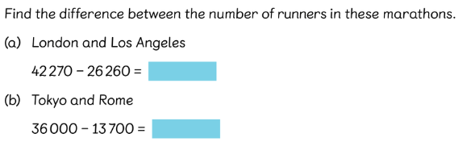  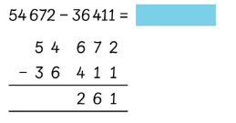  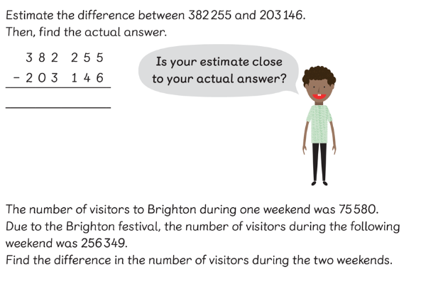 | 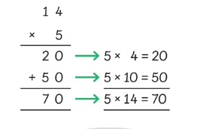  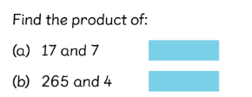  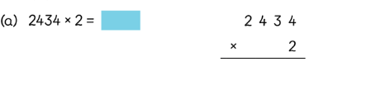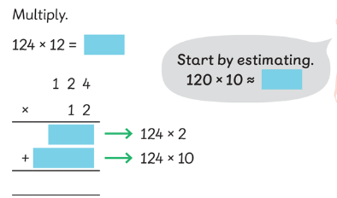 | 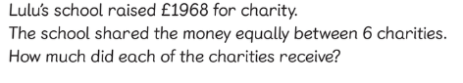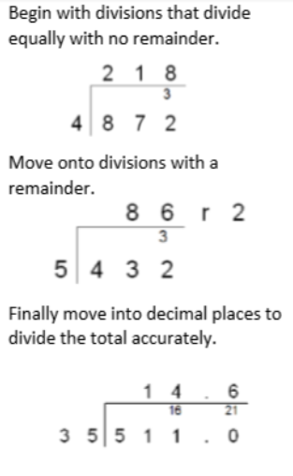

Year 6 | Addition | Subtraction | Multiplication | Division
Concrete  Use a range of concrete resources in each topic.  Base ten, counters etc. | Use methods shown in previous year groups with a range of resources: base ten, counters, numicon etc. | Use methods shown in previous year groups with a range of resources: base ten, counters, numicon etc. | Use methods shown in previous year groups with a range of resources: base ten, counters, numicon etc. | Use methods shown in previous year groups with a range of resources: base ten, counters, numicon etc.
Pictorial | Use methods shown in previous year groups, draw out how to add using counters, part, part whole and bar models. | Use methods shown in previous year groups, draw out how to add using counters, part, part whole and bar models. | 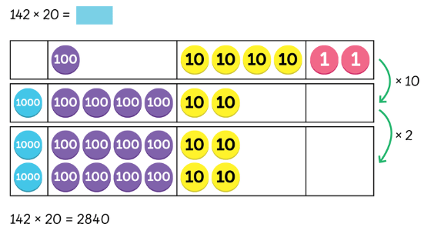 | 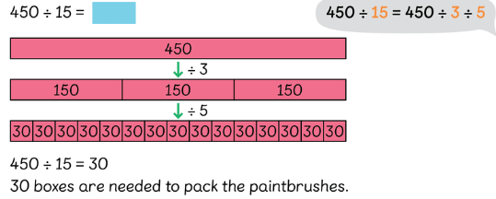
Abstract  Formal written methods to be used. | 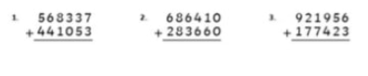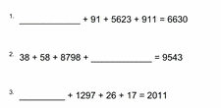  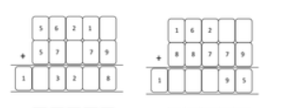  Use worded problems | 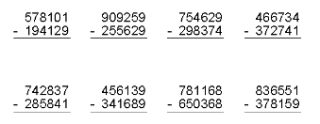  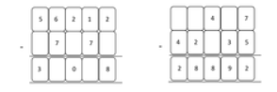  Use worded problems | 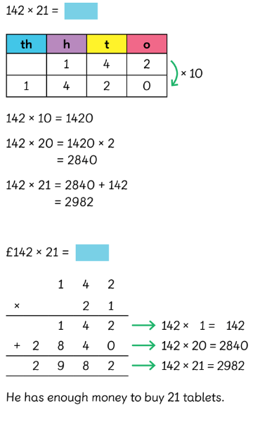  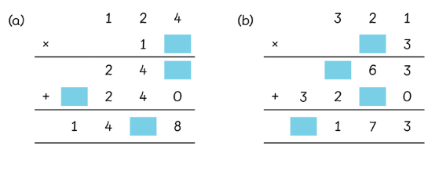  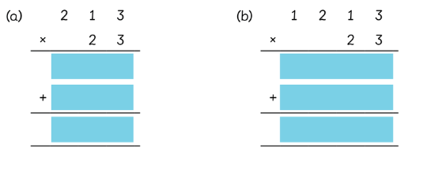  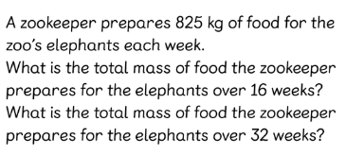 | Long division 

